5.1.2 Compute the PageRank of each page in Fig. 5.7, assuming $β=0.8$.

Page A links to each other two pages and itself.

Page B links to each other two pages

Page C links to Page B and it self.

Thus we can get the transition matrix:

$$M=\left[\begin{matrix}1/3 & 1/2 & 0 \\ 1/3 & 0 & 1/2 \\ 1/3 & 1/2 & 1/2\end{matrix}\right]$$

At the beginning, each of page should be have equal probability and 1/n, Thus the initial PageRank v should be:

$$v=\left[\begin{matrix}1/3 \\ 1/3 \\ 1/3\end{matrix}\right]$$

According to the equation of PageRank, PageRank $v'$ from the current PageRank estimate $v$ will be:

$$v^{'}=βMv+\frac{\left(1-β\right)e}{n}$$

where e is the vector of all 1’s with the appropriate number of components, n is the number of nodes in the page.

And if $β=0.8$, then we can calculate:

$$v^{'}=Mv+\frac{\left(1-β\right)e}{n}=0.8*\left[\begin{matrix}1/3 & 1/2 & 0 \\ 1/3 & 0 & 1/2 \\ 1/3 & 1/2 & 1/2\end{matrix}\right]*v+\left[\begin{matrix}1/15 \\ 1/15 \\ 1/15\end{matrix}\right]$$

We can keep doing like this, then we got:

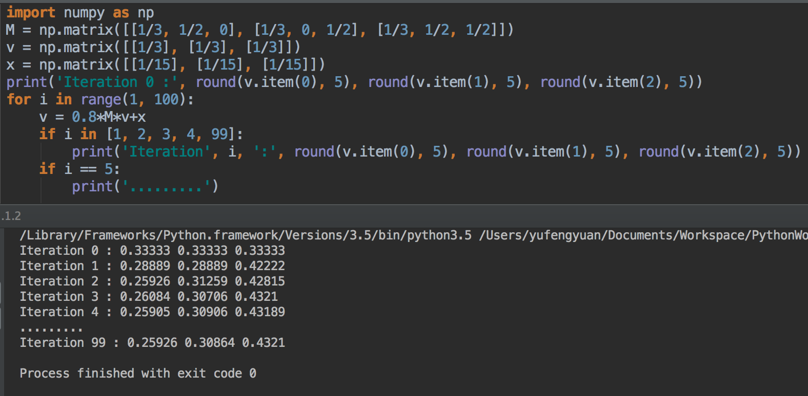

5.3.1 Compute the topic-sensitive PageRank for the graph of Fig. 5.15. Assuming the teleport set is:

1. A only
2. A and C

As same with the first question, we can get the transition matrix as follow:

$$M=\left[\begin{matrix}0 & 1/2 & 1 & 0 \\ 1/3 & 0 & 0 & 1/2 \\ 1/3 & 0 & 0 & 1/2 \\ 1/3 & 1/2 & 0 & 0\end{matrix}\right]$$

And we will still use the equation:

$$v^{'}=βMv+\frac{\left(1-β\right)e}{n}$$

And we assuming the $β$ is same as the first question, where let $β=0.8$

1. For A only, then the initial PageRank should be:

$$v=\left[\begin{matrix}1 \\ 0 \\ 0 \\ 0\end{matrix}\right]$$

In this case:

$$v^{'}=βMv+\frac{\left(1-β\right)e}{n}=0.8*\left[\begin{matrix}0 & 1/2 & 1 & 0 \\ 1/3 & 0 & 0 & 1/2 \\ 1/3 & 0 & 0 & 1/2 \\ 1/3 & 1/2 & 0 & 0\end{matrix}\right]*v+\left[\begin{matrix}1/5 \\ 0 \\ 0 \\ 0\end{matrix}\right]$$

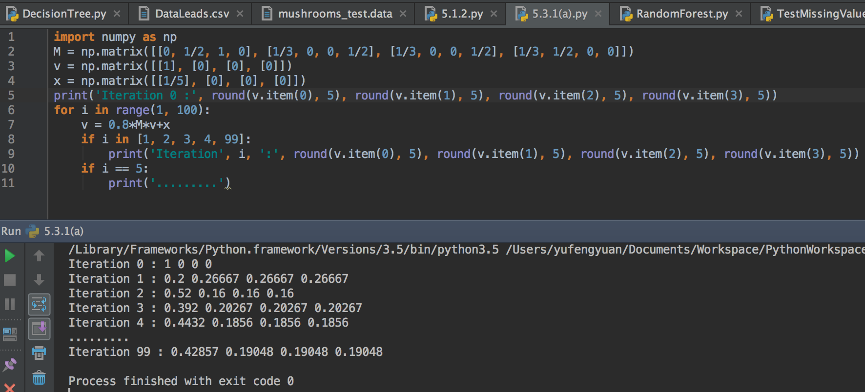

1. For A and C, then the initial PageRank should be:

$$v=\left[\begin{matrix}1/2 \\ 0 \\ 1/2 \\ 0\end{matrix}\right]$$

In this case:

$$v^{'}=βMv+\frac{\left(1-β\right)e}{n}=0.8*\left[\begin{matrix}0 & \frac{1}{2} & 1 & 0 \\ \frac{1}{3} & 0 & 0 & \frac{1}{2} \\ \frac{1}{3} & 0 & 0 & \frac{1}{2} \\ \frac{1}{3} & \frac{1}{2} & 0 & 0\end{matrix}\right]*v+\left[\begin{matrix}1/10 \\ 0 \\ 1/10 \\ 0\end{matrix}\right]$$

